Tutorial

## **Application Demo/Execution steps**

This part of the tutorial will provide you information on how to use the application, explaining the features of the application. We have made the tutorial demo as well, you can refer to the video. Start navigating and exploring as suggested in this Demo video. [AskMe Demo](https://www.youtube.com/watch?v=VvmQ9yZr9HQ)

Steps for application navigation

* + Register as a regular/admin user. Use the Save/Undo/Reset buttons to save the form information, undo and reset to an empty form

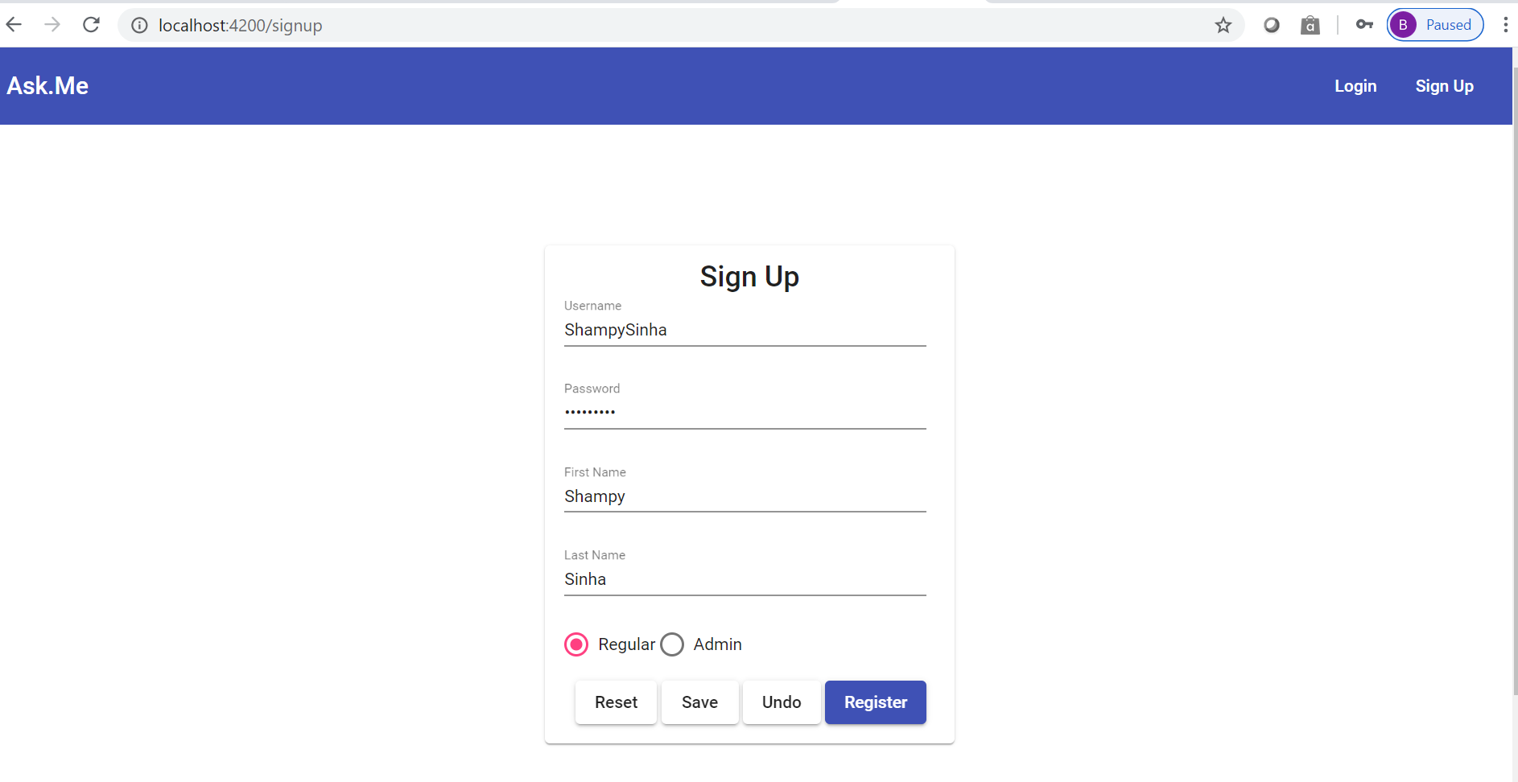

* + Login with the newly created user or one of the existing users

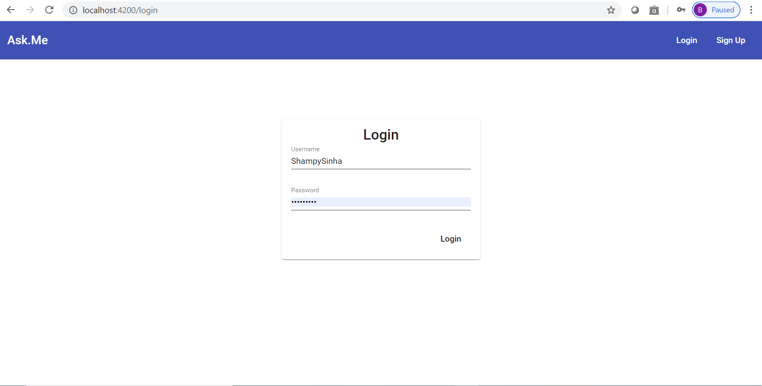

* + User lands on the feed page where he can see the the top most feed of the website.

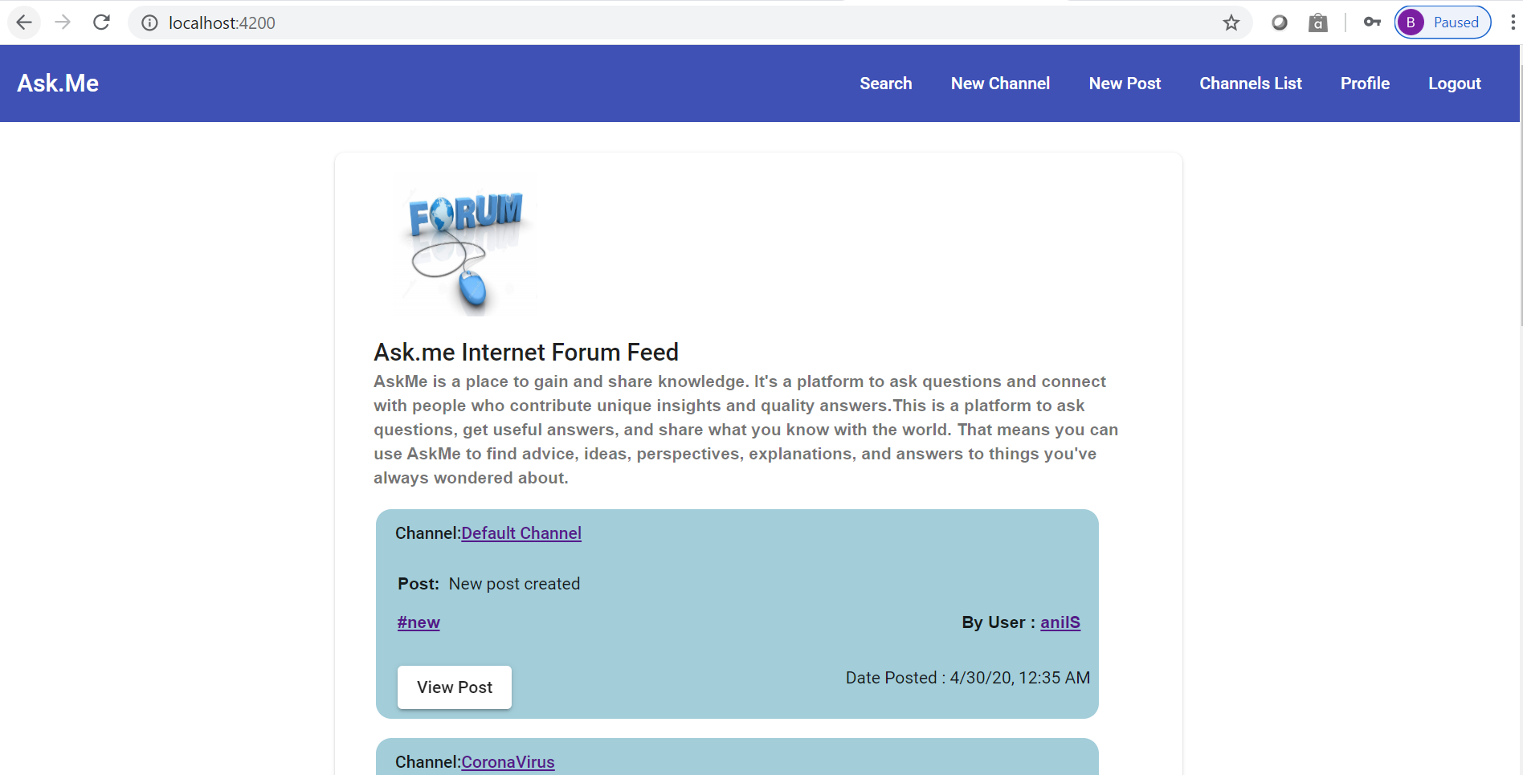

* + User navigates to the channel, hashtag, post or user by clicking on the below highlighted links.

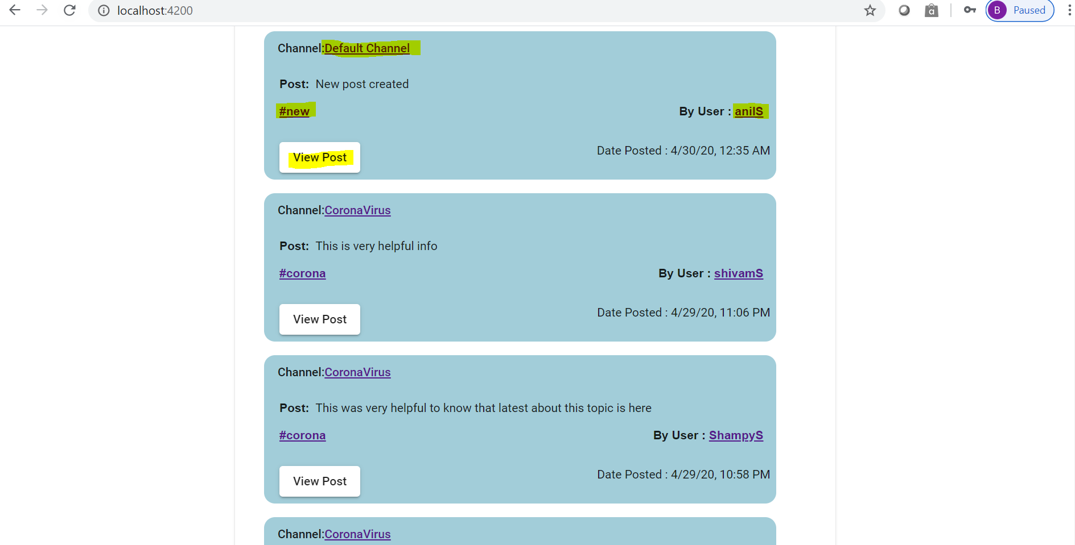

* + Channel Details page.

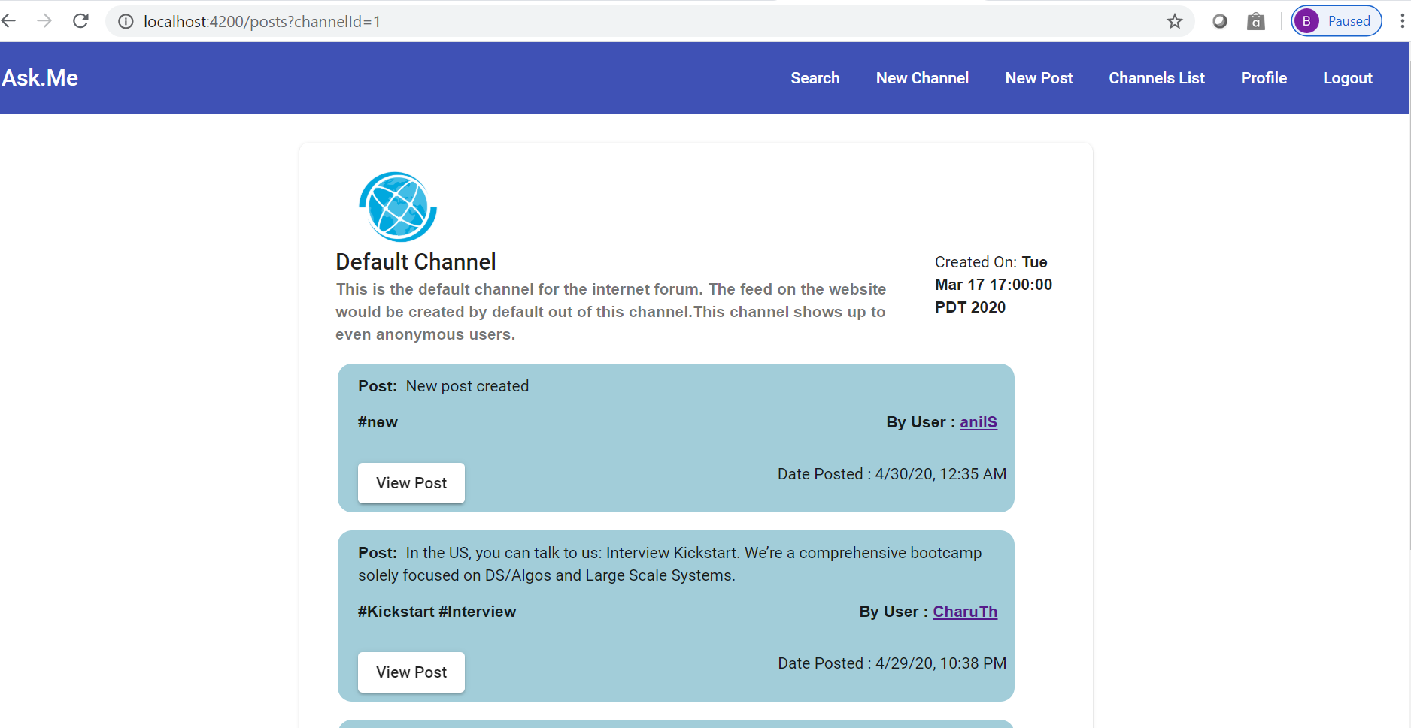

* + Post Details page

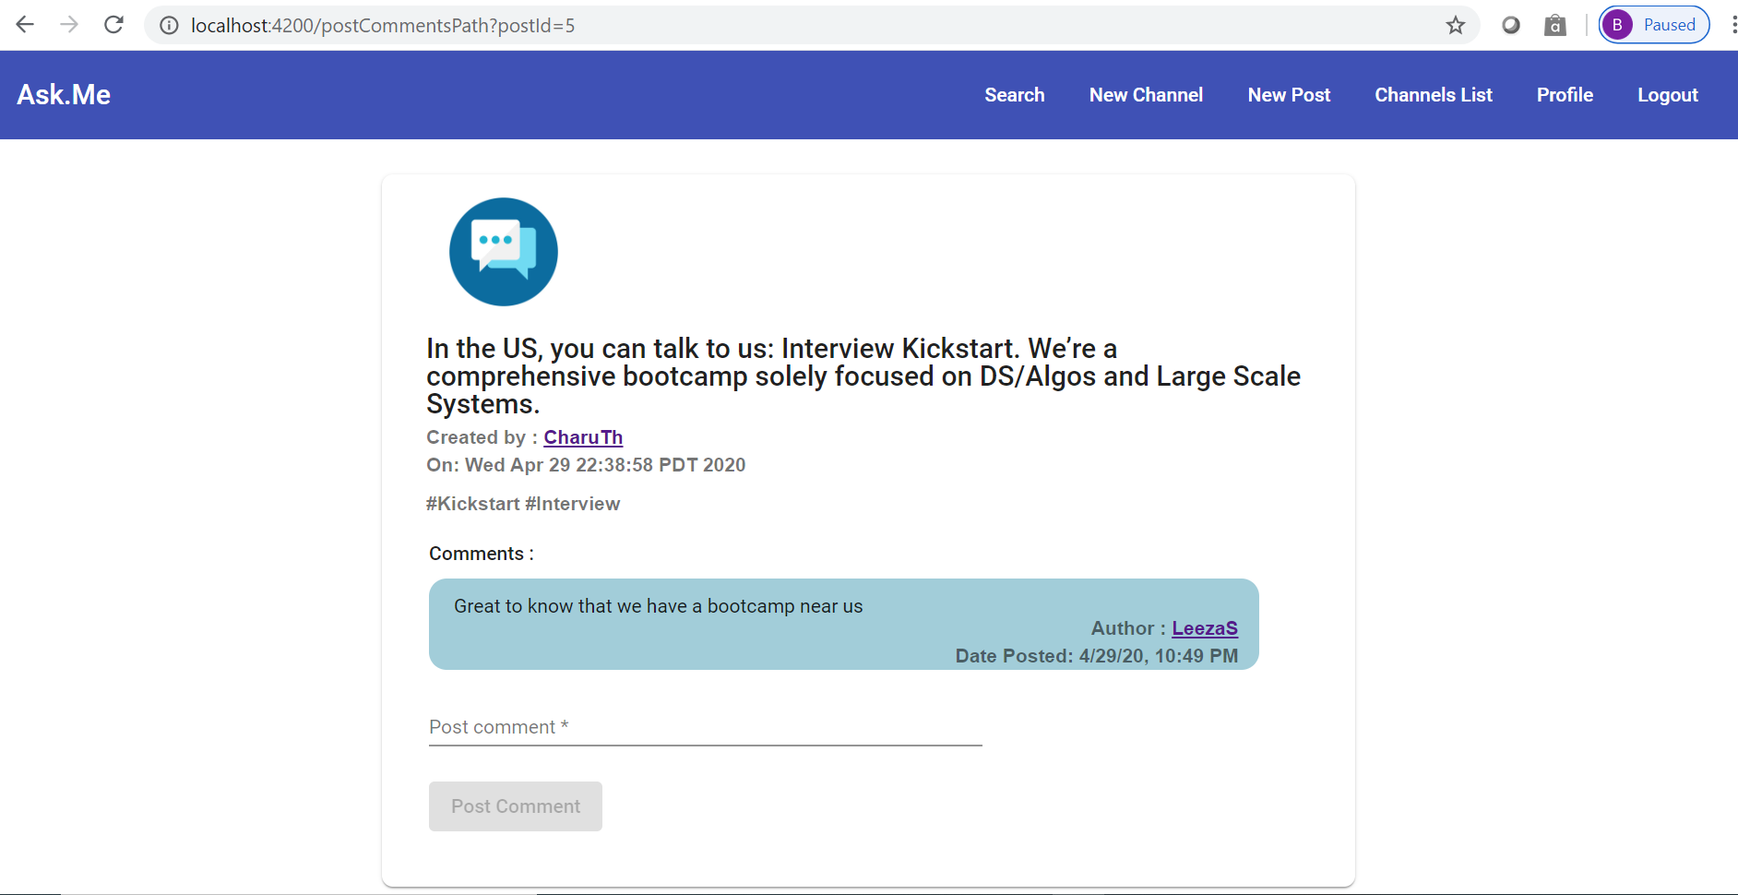

* + User chooses to add a comment on the post, which shows up immediately on submit.

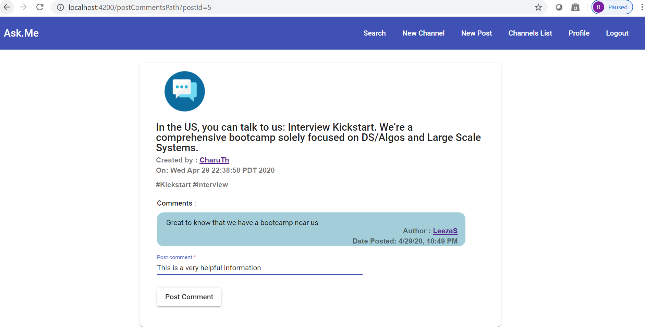

* + Profile details page.

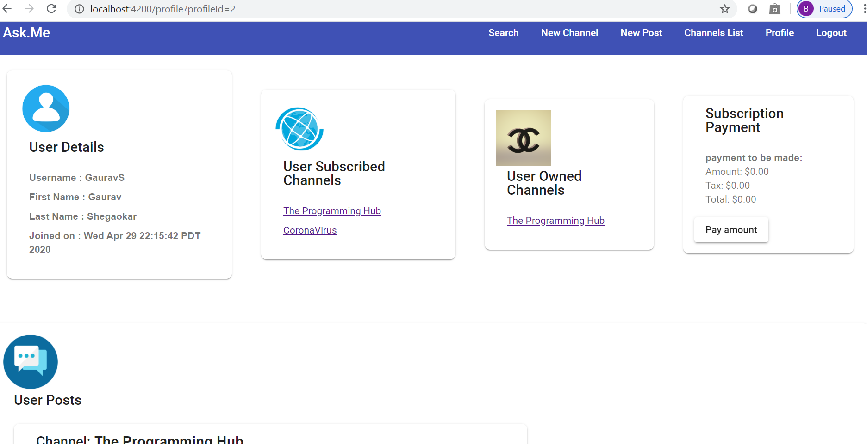

* + User clicks on “Payment amount” to trigger payment, pop up shows up on success.

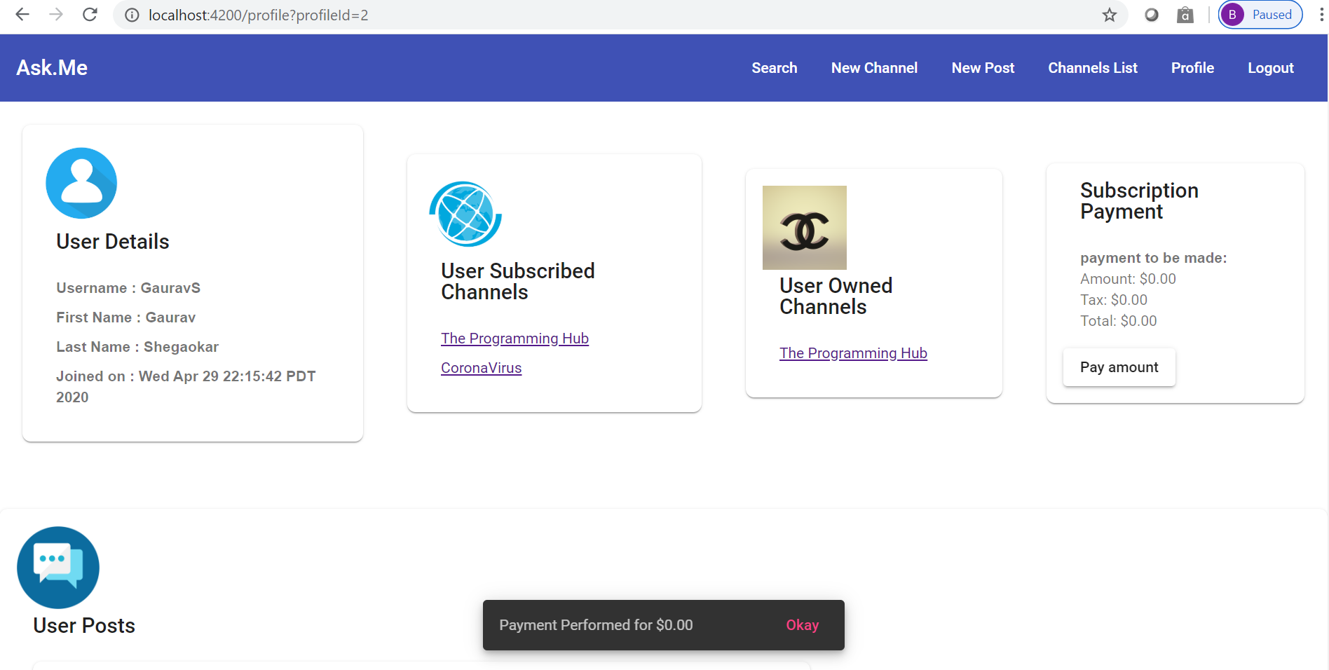

* + User creates a new post in any channel that he is subscribed to.

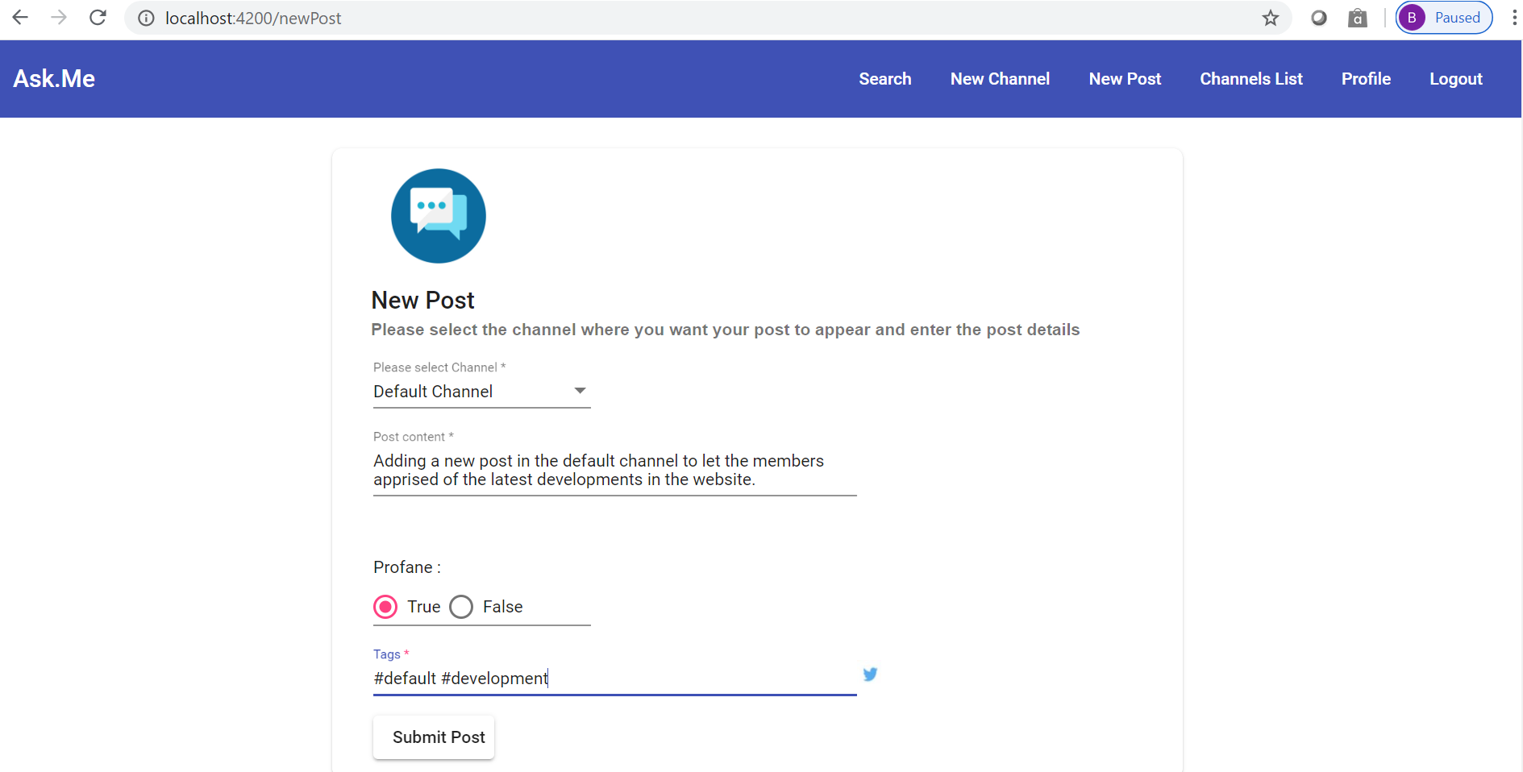

* + User creates a new channel

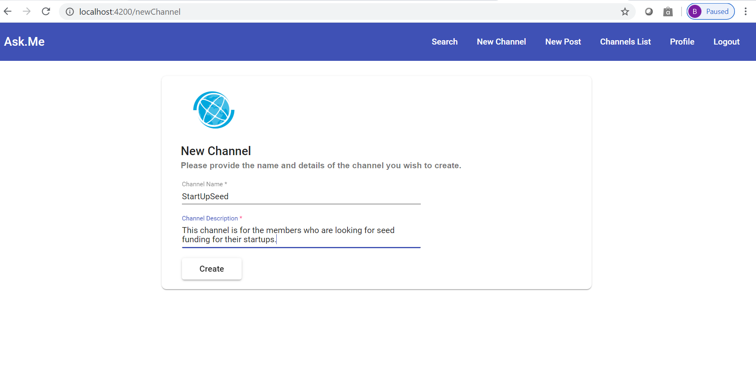

* + User searches for a post or a hashtag

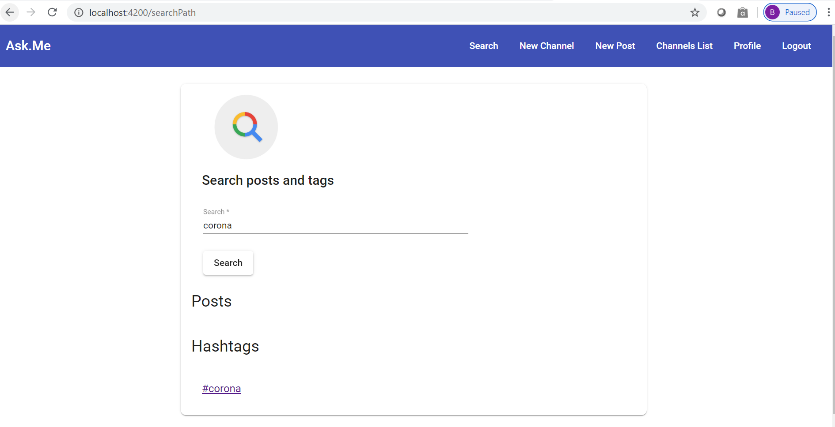

* + User views the list of channels and navigates to view further details.

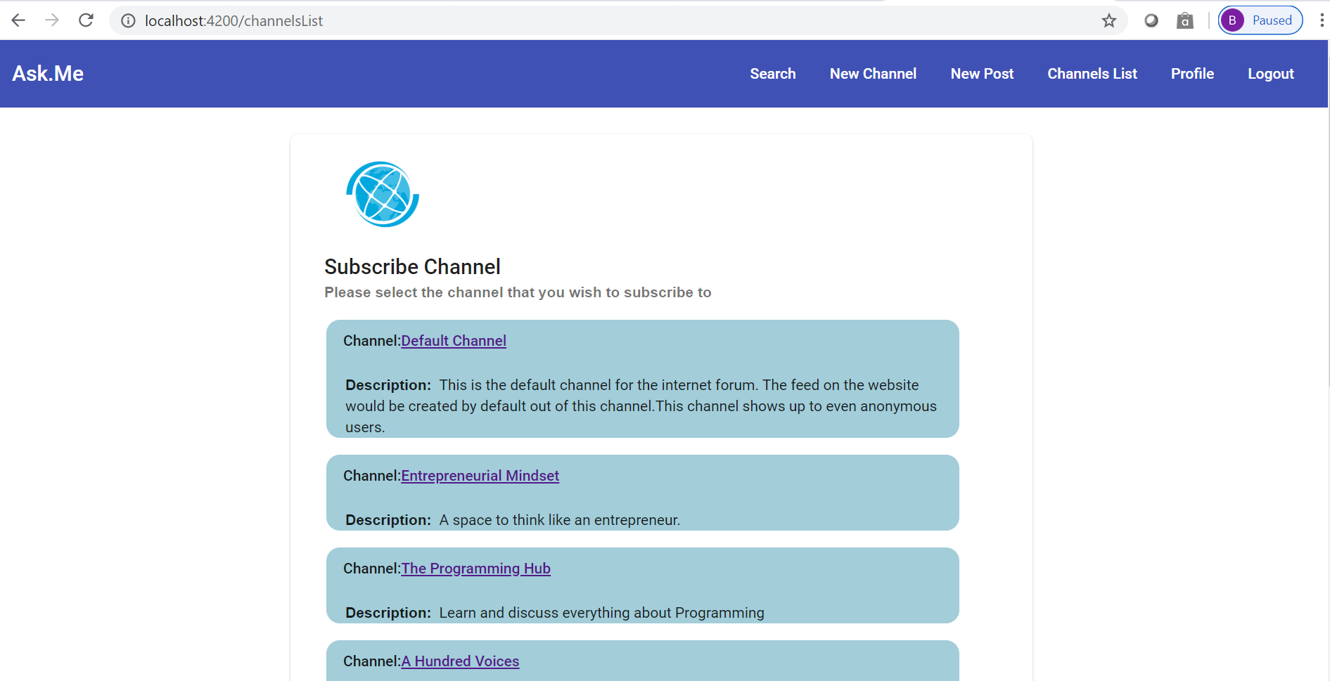

* + On the channels list page, the user can select a channel and subscribe/delete (if he is the owner) a channel.

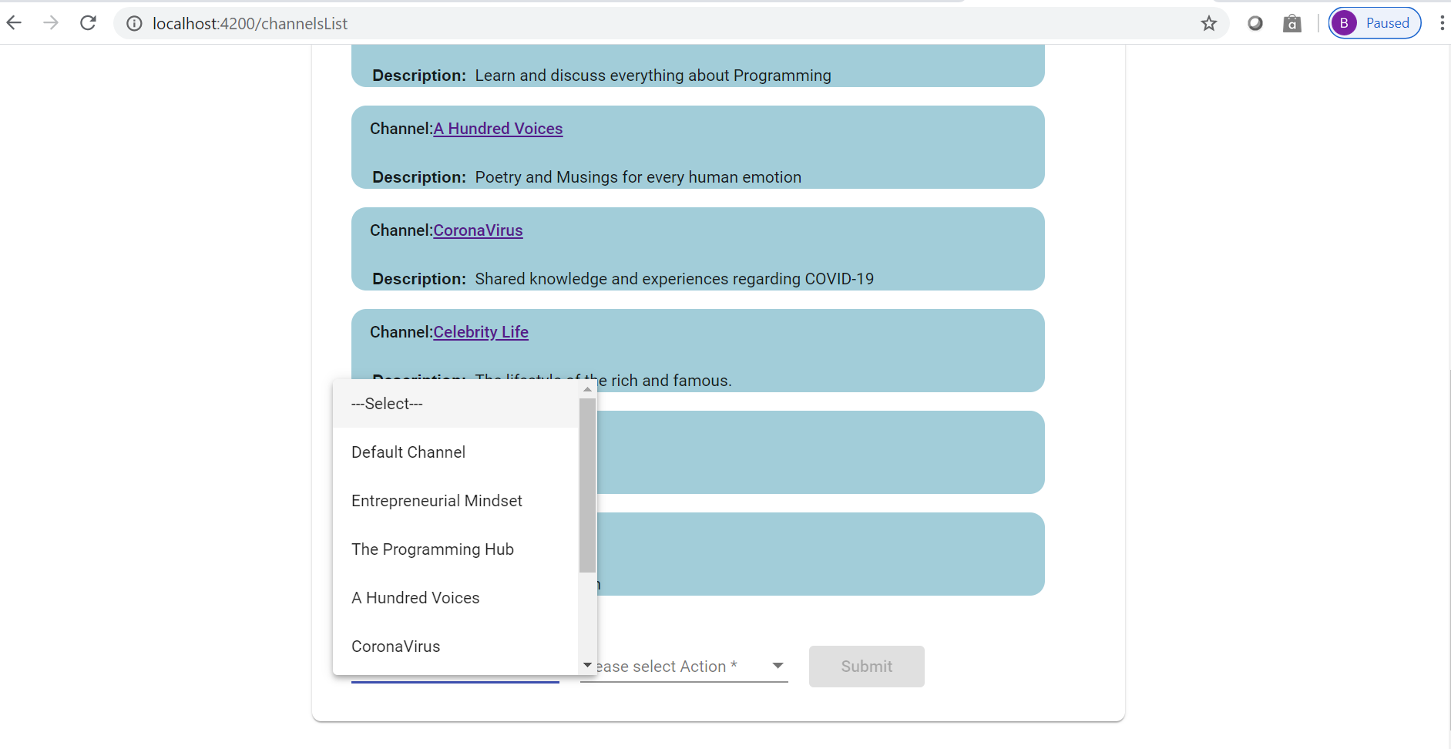

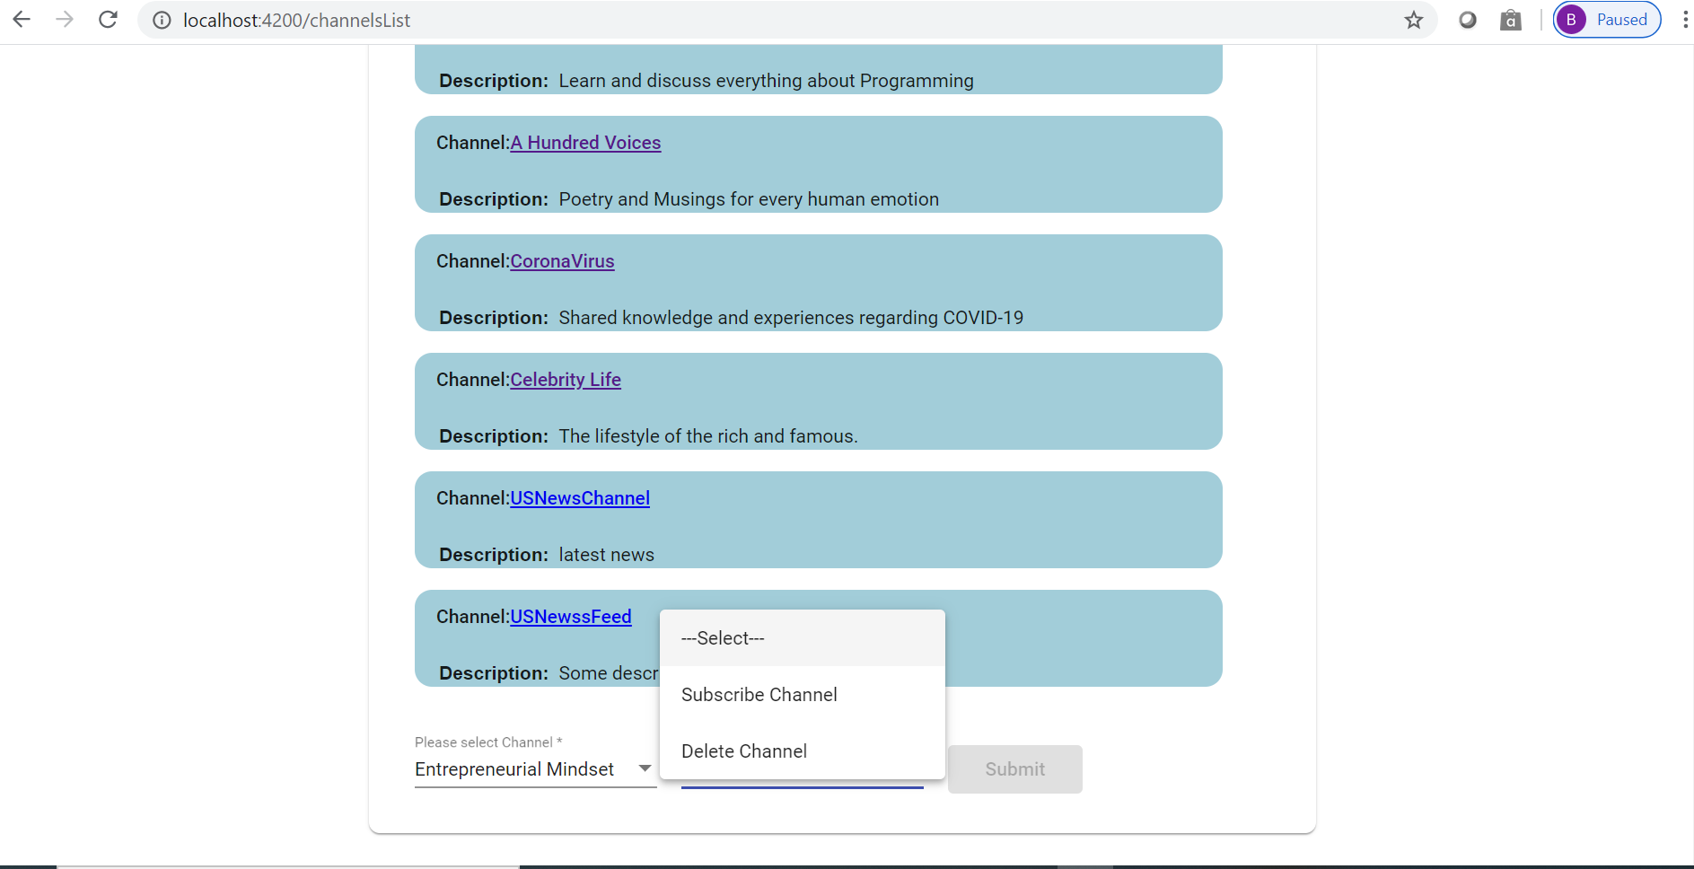

* + The navigation bar has buttons to take users to Home page, Search, New Channel, New Post, Channel List, Profile & Logout.



# 